Name: Abhinay P
Domain: Data Analyst
Project: Twitter Analytics Dashboard-Power Bi
Task 2: Create a clustered bar chart that breaks down the sum of URL clicks, user profile clicks, and hashtag clicks by tweets category (e.g., tweets with media, and tweets with links, tweets with hashtags). Only include tweets that have at least one of these interaction types and this graph should work only between 3PM IST to 5PM IST apart from that time we should not show this graph in dashboard itself and the tweet date should be even number as well as tweet word count be above 40.
Conditions implemented:
The visualization was required to follow all the conditions that are:
- Include only tweets that have at least one interaction type (URL clicks or user profile or hashtag clicks)
- Show data only between 3 PM IST and 5 PM IST
- Include tweets posted on even-numbered dates
- Include only tweets with word count greater than 40
- Hide the visualization completely outside the valid time window
Visualization design
Selected visual: Clustered Bar chart
Configuration
- Axis: Tweet category
- Values: Sum of URL clicks, Sum of User profile clicks, Sum of hashtag clicks
Filters applied
The filters applied directly to the chart are:
- Has any interaction = 1
- Is valid time (3 PM-5 PM IST) =1
- Is even date = 1
- Tweet word count > 40
Result and Data observation:
After applying all the conditions to the chart excluding Tweet word count greater than 40 this is the visual we get.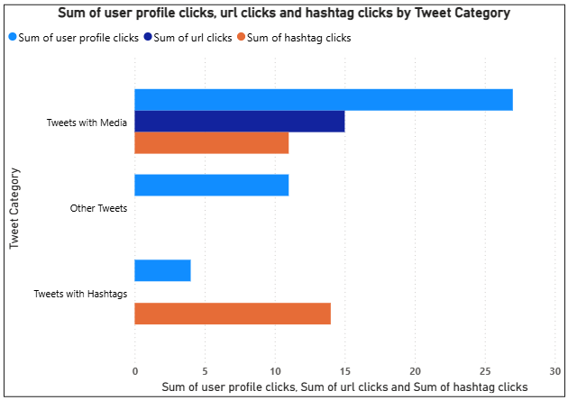
But, after including the condition Tweet word count greater than 40 it is observed that the bars have disappeared meaning even after including all other conditions none of the tweets in the dataset satisfied all the required criteria simultaneously. The absence of data confirms that the filtering logic and DAX calculations were implemented correctly and that the result reflects a limitation of the dataset rather than an issue with the visualization. The dynamic behavior of the chart, which hides itself outside the defined time window, further validates that all business rules were successfully enforced.
Conclusion:
- Proper use of DAX for feature engineering
- correct application of visual-level filters
- Dynamic time-based control of dashboard visibility
- honest handling of data constraints
- professional analytical reasoning.

